ADDENDUM NO. 1

BID NO. 23-11

To all holders of the specifications, the following corrections are hereby made. All other items shall remain unchanged. This addendum shall become part of the Contract Documents for the above referenced project.

Acknowledgement of Addendum

Name: ___________________________________________________

Company: ________________________________________________

Date: ____________________________________________________

Signature: ________________________________________________

Q1: Are there any old plans for the project that show the existing paving section Stone and Paving depth? There is about a two inch gap in the [rink] paving on the ends near the wall is that to be put back in for drainage. Will the city be doing any sealing and pavement markings on the [rink] area?
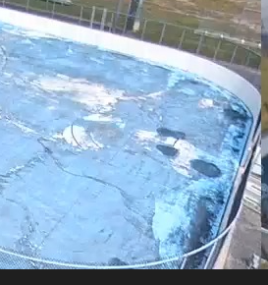

A1: The plans are available via a shared drive. Please email cmaistros@aberdeenmd.gov for the link.
The two inch gap mentioned is pictured here, and will need to be preserved in the new paving as well.
The rink will be sealed, but no markings will be added within this scope of work.

