ADDENDUM NO. 1

BID NO. 23-03
CRESTMONT SEWER REPLACEMENT
HILLCREST MANOR UTL-16-10

To all holders of the specifications, the following corrections are hereby made. All other items shall remain unchanged. This addendum shall become part of the Contract Documents for the above referenced project.

Acknowledgement of Addendum

Name: ___________________________________________________

Company: ________________________________________________

Date: ____________________________________________________

Signature: ________________________________________________

- Section 1: Answers to Questions Posed by Bidders

Q1: Are there any profiles for the new sewer line, or a table with pipe inverts to determine the size of the new manholes to be placed?

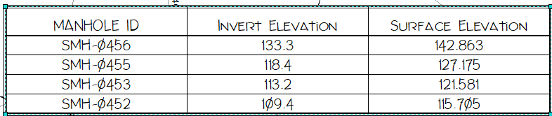
A1: Unfortunately, there are no profiles available for the existing infrastructure at this location. The attached file from 1967 “1 of 1 Planview W-S-RD+SD 7-1-67” shows some information that may be helpful. There is however a table included on Page 01 of the Project Drawings showing existing manhole invert/surface elevations. The new manholes and pipe should be at the same elevation as the existing.

Q2: What size pipe are the sewer service laterals to the cleanouts?

A2: The new sewer service laterals must be 6” SDR-26 PVC from the new sewer main to the cleanout at the parcel boundary. Please see this information and further specifications on Plate S-22; Page 03 of the Project Drawings. The size and material of the existing service laterals on the private side of each parcel boundary are undefined.

