ADDENDUM NO. 2

BID NO. 23-09

LANDSCAPING MAINTENANCE

To all holders of the specifications, the following corrections are hereby made. All other items shall remain unchanged. This addendum shall become part of the Contract Documents for the above referenced project.

Acknowledgement of Addendum

Name: ___________________________________________________

Company: ________________________________________________

Date: ____________________________________________________

Signature: ________________________________________________

Two additional areas will be included with Exhibit A:

The following area “Chesapeake Court Open Space”, consisting of 1.3 acres, shall be included in Exhibit A as Item 34:

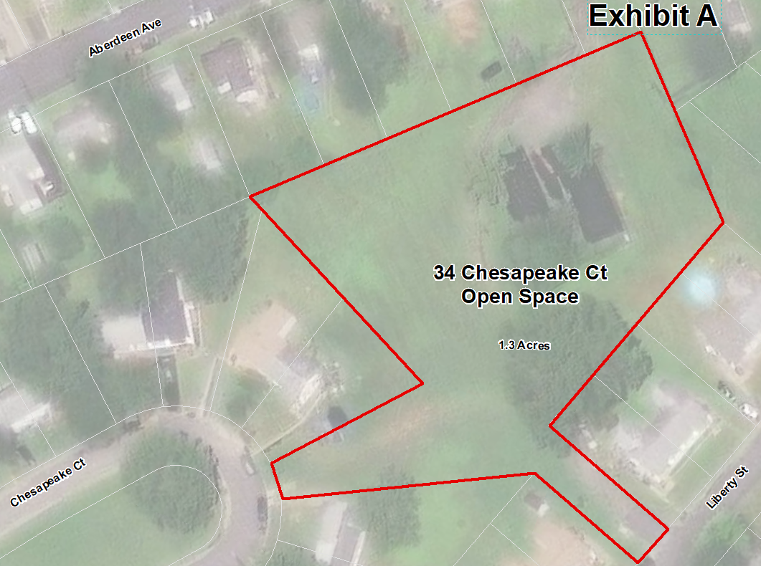

The following area “Chesapeake Court Open Space”, consisting of .70 acres, shall be included in Exhibit A as Item 35:

