CENTERVILLE CITY PERMITTED USE PERMIT FENCES – WALLS – SCREENING CHECKLIST
Permitted Use Permit Fences, Walls, and Screening – Completeness Checklist
The following application, information, fees, and documentation is required for a Permitted Use Permit application completeness review.

Project Name:
Date:
TRACKING HISTORY:
Application Submitted:
Completeness Checklist DRC Meeting (1):
Completeness Checklist DRC Meeting (2)
X –
Application Requirement | Code Reference | Department | Comments
Complete Online Application Form | 12.21.090 | Planning
Application Fees |  | Planning
List of current owners of each property as indicated by current records of the Davis County Recorder’s Office. | 12.21.090 | Planning
Provide a statement describing the proposed changes and why the changes are taking place. | 12.21.090 | Planning
Copies of any agreements with adjacent property owners relevant to the proposed boundary line adjustment. | 12.21.090 (d)(1)(F) | Legal
Signed Property Owner Affidavit | 12.21.090 | Planning/ Legal
Site Plan
One (1) electronic copy | 12.21.090 | Planning
Site address | 12.21.090 | Planning
Property boundaries and dimensions | 12.21.090 | Planning
The location of existing buildings on the lots or parcels | 12.21.090 | Planning
Adjoining property lines and uses within 100 feet of the subject property. | 12.21.090 | Planning
An elevation plan drawn to scale showing elevations of existing and proposed structures | 12.21.090 (d)(1)(F) | Planning
A topographical drawing prepared by a licensed surveyor or civil engineer, showing existing topography in dashed lines at two foot intervals and showing the proposed grade in solid lines at two foot intervals structures (when involves grade changes or in the Hillside Overlay Zone) | 12.21.090 (d)(1)(F) | Planning
A plan showing all retaining walls, including their height relative to proposed grades (when involves fences, walls, grade changes, or in the Hillside Overlay Zone) | 12.21.090 (d)(1)(F) | Planning
The name and addresses of the engineer or surveyor for contacting purposes. | 12.21.090 (d)(1)(F) | Planning
Any existing easements, driveways, utilities and infrastructure improvements | 12.21.090 (d)(1)(F)  12.55.100 | Planning
Table of Development Standards:  - Setbacks from all property lines  - Impervious surface sq ft and %  - Structure heights  - Distance between buildings  - Parking  - Landscape buffering  - Floor area | 12.21.090 (d)(1)(F)  12.31.300  12.32.300  12.33.300  12.34.300  12.35.300 | Planning
Fencing Requirements if being reviewed:
The Zoning Administrator may approve a fence, wall, or similar structure not to exceed a height of eight feet, as a buffering element, where a differing zone district boundary is present | 12.55.110 | Planning
The increased height placement shall be limited to placement or location along a zone district boundary between two differing zones such as:  - When and where there is a difference in zone intensity and the higher intensity zone is missing the buffering element, per CZC 12.51.070  - Between any A-L and R-L Zone boundary. | 12.55.110 | Planning
NO case shall the increased height be placed, located, or extended into any front yard or street side yard setback requirement of any zone | 12.55.110 | Planning
Street Side Yard, Corner Lots:  For residential zones, fencing up to 6 feet in height may be allowed within the street side yard portion of a corner lot  Exception, fences shall not exceed 4 feet in height for a minimum distance of at least 12 feet, when a driveway on an adjacent lot is locate within 12 feet of the interior lot line of the corner lot | 12.55.110 | Planning
Fences in Front Yard and Street Side Yard.  No fence or wall or other similar structure exceeding 48 inches (4 ft) in height shall be erected within a front yard or a street side yard. | 12.55.110 | Planning
A fence, wall, sign, or other similar structure or landscaping located in a required front yard shall meet the following requirements:  - Driveway. No sight-obscuring fence, wall, sign, or other similar structure, or landscaping which exceeds two feet in height shall be placed within a triangular area formed by a driveway line, the street property line, and a line connecting them at points 12 feet along the driveway line and 12 feet along the street property line or back of sidewalk, whichever is greater, except for a reasonable number of trees pruned high enough to permit unobstructed vision for drivers of motor vehicles. ( see below)  - Clear View of Intersecting Street. In all zones, no fence, wall, sign, or other similar structure, or landscaping which exceeds two feet in height shall be placed on any corner lot within a triangular area formed by the street property lines and a line connecting them at points 30 feet from the intersection of the street curb lines, except for public safety signs and equipment. ( see below) | 12.55.230 | Planning
Wall Requirements if being reviewed:
A plan showing all retaining walls, including their height relative to proposed grades | 12.42 | Engineering
No wall, or other similar structure exceeding six feet in height shall be erected in any rear or side yard | 12.55.110 | Planning
When a difference in grade exists on either side of a fence or wall, the height of the fence or wall shall be measured from:  The average elevation of the finished grade of adjoining properties at the fence line; or  If excavated or filled, the native elevation. | 12.55.110 | Engineering
If located in the hillside overlay, the site plan will need to include the additional items provided by a Utah certified engineer with stamps:  - A slope district map reflecting existing slope conditions prior to development at a scale of 1" = 100' and an estimate of the average slope of the proposed development  - A topographic contour map, tied to a land base survey, delineating areas within the development site with slopes of less than 10%, areas between 10% and 20%, areas between 21% and 30%, and areas greater than 30%, shall be designated topographic contours at two foot intervals for slopes up to 20% and five foot intervals for slopes greater than 20%.  - Location of known hazards (i.e., faults, drainage, rock fall, landslide, slump, etc.).  - Soil type and general description of soil types to a depth of five feet.  - Land use data, (i.e., the amount of residential land, transportation land, etc.), by acreage and percent.  - Existing vegetation-type map | 12.42 | Engineering
The city engineer may request the following studies:  - Soil Characteristics Report.  - Vegetation Report.  - Geologic Conditions Report.  - Grading and Drainage Report. | 12.42 | Engineering
If located in the hillside overlay, retaining walls shall be used to retain existing slope or graded slope as may be approved by the City Engineer. | 12.42 | Engineering
If located in the hillside overlay, the height of necessary and approved retaining walls shall be a maximum of eight feet. Extensive "rear yard" retaining walls built for the purpose of leveling a yard by backfilling, are expressly prohibited. | 12.42 | Engineering
If located int eh South Main Street Corridor Zone, Where an off-street parking lot is visible from the street in a side-yard, it shall be screened by either a two foot tall screen wall or 18 inch seat wall located between the parking lot and the sidewalk.  Where a parking lot is adjacent to a single-family residential district, a three foot screen wall and landscaping, sufficient to screen up to the headlight level of vehicles, shall be located between the residential use and the parking lot. | 12.48.160 (b)(2) | Planning
Screening Requirements if being reviewed:
Trash receptacles shall be screened from view by a wall or fence which:  - Is at least six feet in height  - Provides complete visual screening of the receptacle  - Is compatible in material and color with the main building on the lot or parcel | 12.51.110 | Planning
Outdoor storage areas, limited to the following zones:  A-M  PF-L(only Parking of motor vehicles)  PF-M(only Parking of motor vehicles)  PF-H (only Parking of motor vehicles)  PF-VH (only Parking of motor vehicles)  C-M ( located at least 50 feet from any residential zone boundary)  C-H( located at least 50 feet from any residential zone boundary)  C-VH (located at least 50 feet from any residential zone boundary)  I-M ( located at least 100 feet from any residential zone boundary)  I-H( located at least 100 feet from any residential zone boundary)  I-VH (located at least 100 feet from any residential zone boundary)  Shall be screened from view by an opaque fence or wall. Non-opaque fencing, such as powder or vinyl coated chain-link, may be used to satisfy this requirement in industrial zones if vinyl slats are inserted into the fence. | 12.51.110 | Planning
Service and loading areas in multiple-family residential, public facility, commercial, or I-M zones shall be screened from public view | 12.51.110 | Planning
Ground mounted utility boxes, meters, and mechanical equipment in multiple-family residential, public facility, commercial, or I-M zones shall be screened from public view by landscaping or architectural elements compatible in material and color with the main building on the lot or parcel.  This requirement shall not apply to:  Rear and rear side yard locations adjacent to other service or mechanical areas not adjacent to a public street and development in agricultural and R-L Zones. | 12.51.110 | Planning
Roof mounted mechanical equipment shall be concealed by material which is consistent with building design and is equal to or greater in height than the mechanical equipment. | 12.51.110 | Planning

A landscape plan will be required when the fence, wall, or screening involves landscaping.
After an application is determined to be complete in accordance with CZC 12.21.040(e), the Zoning Administrator shall approve, approve with conditions, or deny the application.
Any conditions of approval shall be limited to conditions needed to conform the permitted use to approval standards, see below:
  - Be allowed as a permitted use in the applicable zone- CZC 12. 36 has the table of use. CZC 12. 12 has the definitions for each use
  - Conform to development standards of the applicable zone- CZC 12.31 is the Agriculture development standards, CZC 12.32 is the Residential development standards, CZC 12.33 is the Public Facilities development standards, CZC 12.34 is the Commercial development standards, CZC12.35 is the Industrial development standards
  - Conform to applicable regulations of general applicability and regulations for specific uses set forth in the Permitted Use Review, CZC 12.21.090 and CZC 12.21.040
  - Conform to any other applicable requirements of the Centerville Municipal Code including the CZC 12.51 Landscaping and Screening
Conditions may be imposed as necessary to achieve conformance with applicable code requirements.
If proposed development is located on a parcel, the development and permitted use permit approval shall be subject to CZC 12.55.132 (Development or Use of Parcel).

Visuals

Fencing permitted areas
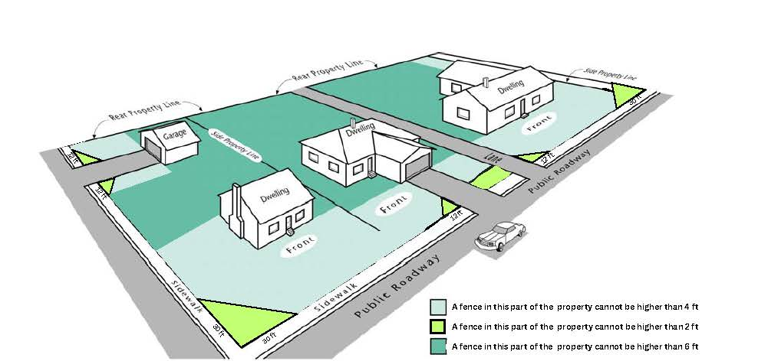

Driveway Sight Triangles
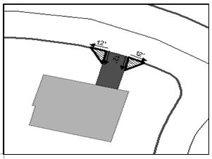

Street Intersection Sight Triangles
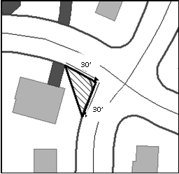
Rock walls
