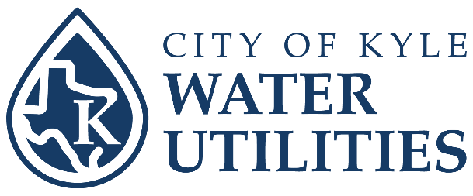
Residential Rain Barrel Rebate Program

Customer Name: |  | Date:
E-mail: |  | Phone #:
Service Address:
Mailing Address:

Instructions: Kyle Water Utility and Kyle Stormwater Drainage Utility customers are eligible for up to $200 for one 50-gallon (minimum) rain barrel and associated installation components or accessories.

- Sales tax, shipping, and delivery fees are not eligible for reimbursement.
- Limited to one application per household.
- Rain barrel installation must be reviewed with an HOA, if applicable.
- Original receipt(s) of purchase and photos showing proof of installation are required.
- Email this completed form, your last utility bill, original receipt(s) of purchase, and photos showing proof of installation to wcrp@cityofkyle.com.

Rebate Item | Total Amount of Receipts | Maximum Rebate Amount | Rebate Amount
Minimum 50-gallon Rain Barrel & Accessories |  | $200

□ I acknowledge that I have followed all above instructions.

Customer Signature:_________________________________________ Date:_______________

For Staff to Complete
Date received by Water Utilities for approval:
Date processed:
Date sent to Finance for payment:

Revised July 2026

