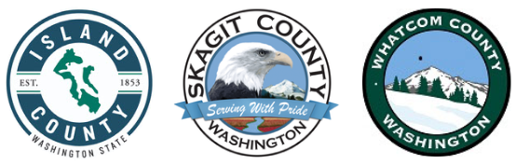

Skagit County HOME Consortium
TBRA Renewal Funding Application
Cover Sheet
ORGANIZATION INFORMATION
Organization name: Click or tap here to enter text.
Type of organization: ☐ Nonprofit ☐ For Profit ☐ Government ☐ Other
- If your organization has a nonprofit status, please provide a copy of your current IRS 501(c)3 status letter with your application.
- Provide a current list of your organization’s board members with your application.
Business Address: Click or tap here to enter text.
Phone Number: Click or tap here to enter text. Fax: Click or tap here to enter text.
Federal ID#: Click or tap here to enter text.
DUNS# Click or tap here to enter text.The Dun and Bradstreet, D-U-N-S, Number is a unique nine-digit identification sequence that provides unique identifiers of businesses. D-U-N-S numbers are now required by the U.S. Federal Government. Their website is located at http://www.dnb.com/duns-number.html .
Applicants must be registered with sam.gov through this link to enable verification that the applicant is not listed as a debarred, suspended, or ineligible contractor. Please provide the sam.gov registration number: Click or tap here to enter text.

APPLICATION CONTACT INFORMATION
Name and Position: Click or tap here to enter text.
Email: Click or tap here to enter text.
Phone: Click or tap here to enter text.
REQUIRED ATTACHMENTS
Please include the following documentation as an attachment:
☐TBRA Renewal Funding Application
☐Fiscal Documentation
- Complete federal Single Audit reports for prior two years
  - Any audit findings, corrective action plan, management letter, and agency response
- Nonprofit Organizations: IRA Form 990, prior two years

☐Application Certification

☐Conflict of Interest Certification

